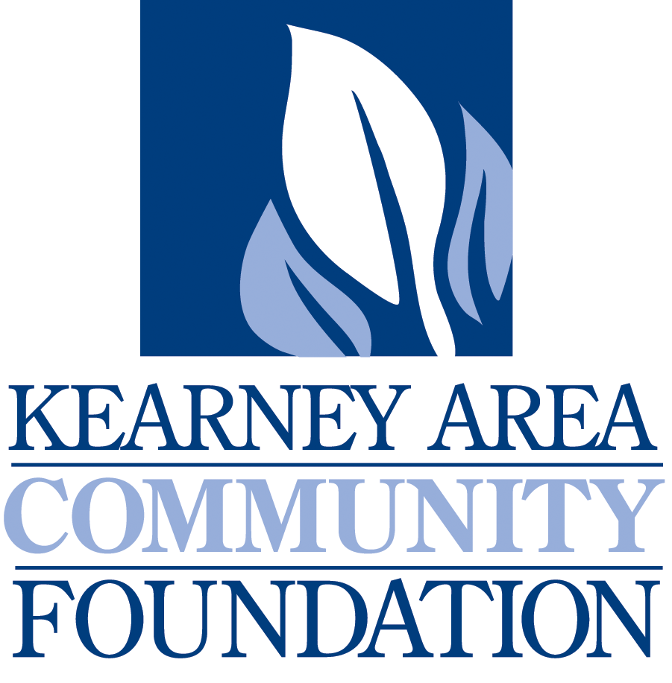
IMMEDIATE RELEASE

NEWS RELEASE

October 14, 2016
For more information:
Judi Sickler, Executive Director
Kearney Area Community Foundation
308-237-3114

Hadleys, Bascom and K-Town Shakedown to be Honored for Community Giving

The Kearney Area Community Foundation will award the 11th annual “Celebration of Giving” Philanthropy Awards November 10. The Community Foundation will be honoring Galen and Marilyn Hadley, Roxanne Bascom and K-Town Shakedown.

The “Celebration of Giving” Philanthropy Awards will honor individuals and businesses that have encouraged and supported charitable stewardship in the Kearney area. Three awards will be given in the categories of Philanthropist, Volunteer and Corporate.

Philanthropist: Given to an individual or family who has demonstrated outstanding civic and charitable stewardship in or around the Kearney area, and whose generosity motivates others to contribute their philanthropic support.

Volunteer: Given to an individual who has contributed their time and energy to successful fundraising efforts, through exceptional leadership in coordinating and/or motivating other volunteers to raise funds in or around the Kearney area.

Corporate: Given to a business/corporation in or around the Kearney area which has contributed financial support to the advancement of philanthropy, and which has encouraged employees and other businesses to contribute through volunteerism and financial support.

Galen and Marilyn Hadley will be awarded the Philanthropist Award; Roxanne Bascom will be awarded the Volunteer Award; and K-Town Shakedown will be awarded the Corporate Award.

Awards will be presented at the Kearney Area Community Foundation Annual Dinner November 10, 2016, at the Younes Conference Center. Reservations can be secured for $40.00 by contacting the Kearney Area Community Foundation before November 3.

The Kearney Area Community Foundation is located at 412 W. 48th Street, Suite #12. Contact us at 308-237-3114 or by emailing kacf@kearneyfoundation.org.

END

